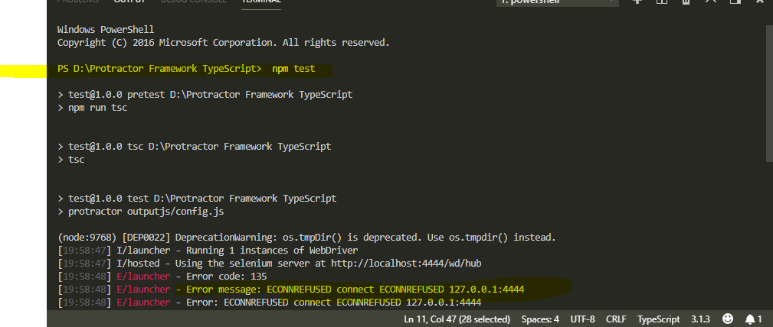

Solution: Check whether webdriver manager server is running or not. If not, then run it to solve it.

$ webdriver-mangaer start

Solution : After starting the server, the issue is resolved

